MEGHNAD SAHA INSTITUTE OF TECHNOLOGY

*Techno Complex, Madurdaha,Beside NRI Complex, Post-Uchhepota, Kolkata 700 150*

LABORATORY NOTE BOOK

MAKAUT ODD SEMESTER 2024



[MASTERS OF COMPUTER APPLICATION]

[RELATIONAL DATABASE MANAGEMENT SYSTEM LAB (MCAN192)]

[RUPAK SARKAR]

ROLL NO: REGN. NO.:

STREAM: MCA SEMESTER: I (1ST)

YEAR: 1ST YearSESSION: 2024-2026



MAULANA ABUL KALAM AZAD UNIVERSITY OF TECHNOLOGY



MEGHNAD SAHA INSTITUTE OF TECHNOLOGY

*Techno Complex,. Madurdaha,Beside NRI Complex, Post-Uchhepota, Kolkata 700 150*

“LIST OF ASSIGNMENT/EXPERIMENT SUBMISSION DETAILS”

|  |  |  |  |  |  |
| --- | --- | --- | --- | --- | --- |
| **SL.**  **NO.** | **ASSIGNMENT / EXPERIMENT NAME** | **PLANNED DATE OF SUBMISSION** | **ACTUAL DATE OF SUBMISION** | **CHECKED BY** | **REMARKS (ANY DEVIATION REGARDING SUBMISSION DATES, CONTENT, FORMAT, ETC)** |
|  |  |  |  |  |  |
|  |  |  |  |  |  |
|  |  |  |  |  |  |
|  |  |  |  |  |  |
|  |  |  |  |  |  |
|  |  |  |  |  |  |
|  |  |  |  |  |  |
|  |  |  |  |  |  |
|  |  |  |  |  |  |
|  |  |  |  |  |  |

|  |
| --- |
| OBSERVATIONS / COMMENTS ON THE OVERALL PERFORMANCE: |

Signature in full with date Signature in full with date

**Faculty / Technical Assistant Lab Examiner**

**Create a table EMPLOYEE with following schema:**

**(Emp_no, E_name, E_address, E_ph_no, Dept_no, Dept_name, Job_id, Salary, City, Email)**

Ans: To create a Table named EMPLOYEE with the given attributes, we write the following command –

**SQL Query –** CREATE TABLE EMPLOYEE(EMP_NO NUMBER(3), E_NAME CHAR(10), E_ADDRESS VARCHAR2(30), E_PH_NO NUMBER(10), DEPT_NO VARCHAR2(5), DEPT_NAME CHAR(10), JOB_ID CHAR(5), SALARY NUMBER(10), CITY VARCHAR2(15), EMAIL VARCHAR2(20));

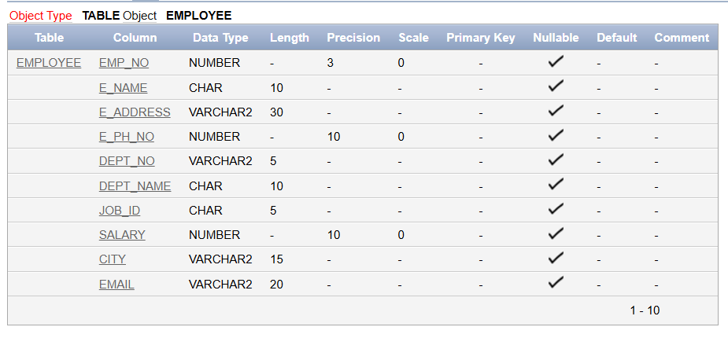

**Q.1. Insert atleast 5 rows in the table employee.**

Ans:

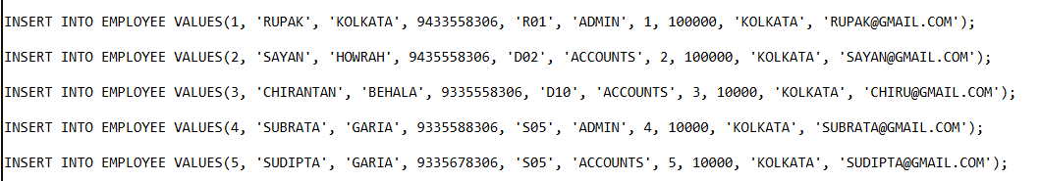

**Q.2. Display all the information of employee table.**

Ans: To display all the information of the Employee table, we write the following query.

**SQL Query –** SELECT * FROM EMPLOYEE;

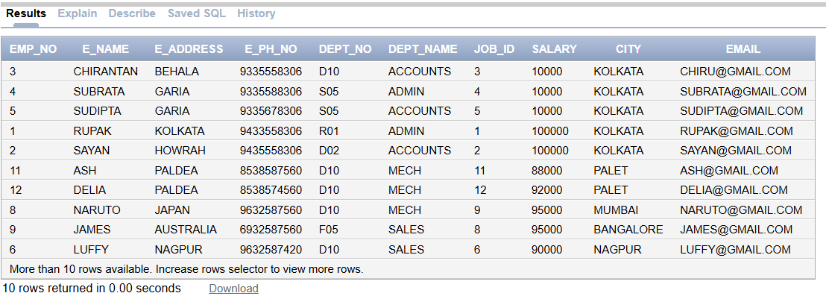

**Q.3. Display the records of each Employee who works in Department D10.**

Ans: To display the records of each Employee who works in Department D10, we need to write the following query.

**SQL Query –** SELECT * FROM EMPLOYEE WHERE DEPT_NO='D10';

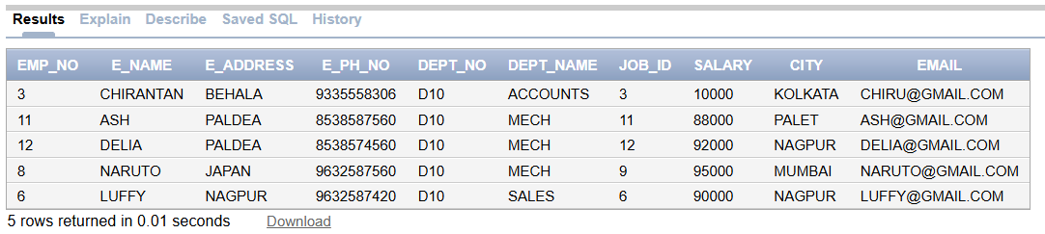

**Q.4. Update the city of employee number 12 with current city as Nagpur.**

Ans: To update the city of employee 12 as Nagpur, we need to write the following query.

**Before Updation –**

**SQL Query –** SELECT * FROM EMPLOYEE WHERE EMP_NO=12; **(To view the record of Employee 12.)**

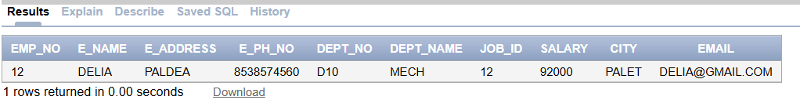

**After Updation –**

**SQL Query –** UPDATE EMPLOYEE SET CITY='NAGPUR' WHERE EMP_NO=12;

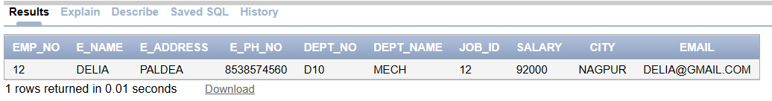

In the above two screenshots, we can see that the City field of Employee-12 has been changed from Palet to Nagpur.

**Q.5. Display the details of Employees who work in the Department MECH.**

Ans: To display the details of Employees who work in the MECH Department, we need to write the following query.

**SQL Query –** SELECT * FROM EMPLOYEE WHERE DEPT_NAME='MECH';

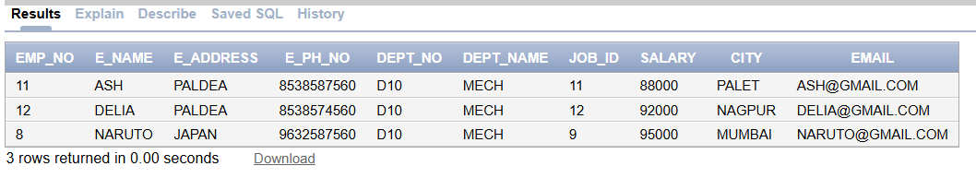

**Q.6. Delete the Email ID of Employee James.**

Ans: To delete the Email ID of employee James, we need to write the following query.

**Before Deletion –**

**SQL Query –** SELECT * FROM EMPLOYEE WHERE E_NAME='JAMES'; (This query is used to view the details of employee James.)

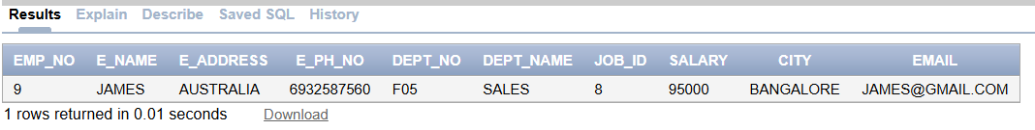

**After Deletion –**

**SQL Query –** UPDATE EMPLOYEE SET EMAIL = '' WHERE E_NAME = 'JAMES'; (This query sets the Email field of employee James to an empty string.)

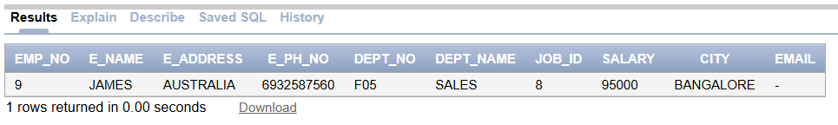

**Q.7. Display the complete record of Employees working in Sales Department.**

Ans: To display the complete records of Employees working in Sales Department, we need to write the following query.

**SQL Query –** SELECT * FROM EMPLOYEE WHERE DEPT_NAME='SALES';

